1. What is the size of MBR and what does it contains.

* Master Boot Record (MBR) is the information in the first sector of any hard disk or diskette that identifies how and where an operating system is located so that it can be boot(loaded) into the computer's main storage or ram.
* The Master Boot Record is also sometimes called the "partition sector" or the "master partition table" because it includes a table that locates each partition that the hard disk has been formatted into.
* MBR also includes a program that reads the boot sector record of the partition containing the operating system to be booted into RAM. In turn, that record contains a program that loads the rest of the operating system into RAM.

1. In which file you can write commands which you want to run whenever Linux system starts/restarts?

Using Rc local:we will use ‘rc.local’ file located in ‘/etc/’ to execute our scripts and commands at startup. We will make an entry to execute the script in the file & every time when our system starts, the script will be executed.

1. Reboot the system using runlevel.

Init 6

0- Halt

1- Single user mode (recovery)

2- Debian/Ubuntu default

3- RHEL/Fedora/SUSE text mode

4- free

5- RHEL/Fedora/SUSE graphical mode

6- reboot

1. Restart cron service.

Sudo service cron start

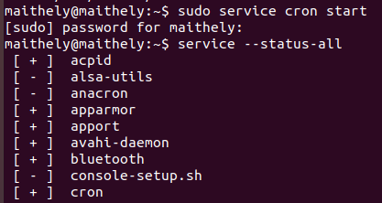

1. Create an ext4 filesystem

mkfs –t ext4 /dev/sda3

1. Mount the created filesystem on /partition directory.

sudo mount /dev/sda3 /mnt/media

1. Difference between LVM and RAID.

|  |  |  |
| --- | --- | --- |
| **S.No.** | **RAID** | **LVM** |
| 1. | RAID is used for redundancy. | LVM is a way in which you partition the hard disk logically and it contains its own advantages. |
| 2. | A RAID device is a physical grouping of disk devices in order to create a logical presentation of one device to an Operating System for redundancy or performance or a combination of the two. | LVM is a logical layer that that can be anipulated in order to create and, or expand a logical presentation of a disk device to an Operating System. |
| 3. | RAID is a way to create a redundant or striped block device with redundancy using other physical block devices. | LVM usually sits on top of RAID blocks or even standard block devices to accomplish the same result as a partitioning, however it is much more flexible than partitions. You can create multiple volumes crossing multiple physical devices, remove physical devices without loosing data, resize the volumes, create snapshots, etc |
| 4. | RAID is either a software or a hardware technique to create data storage redundancy across multiple block devices based on required RAID levels. | LVM is a software tool to manage large pool of storage devices making them appear as a single manageable pool of storage resource. LVM can be used to manage a large pool of what we call Just-a-bunch-of-Disk (JBOD) presenting them as a single logical volume and thereby create various partitions for software RAID. |
| 5. | RAID is NOT any kind of Data backup solution. Its a solution to prevent one of the SPOFs (Single Point of Failure) i.e. DISK failure. By configuring RAID you are just providing an emergency substitute for the Primary disk. It NEVER means that you have configured DATA backup. | LVM is a disk management approach that allows us to create, extend, reduce, delete or resize the volume groups or logical volumes. |

1. Create a LVM(Slide 13)

=> -Select the Physical Storage Devices for LVM

$pvcreate /dev/sda1 /dev/sda2

-Create the Volume Group

$vgcreate vol_grp1 /dev/sda1 /dev/sda2

-Create Logical Volumes

$lvcreate -l 20 -n logical_vol1 vol_grp1

1. Create a RAID1 device(Slide 19)

# mdadm --create /dev/md0 --level=mirror --raid-devices=2 /dev/sd[b-c]1

# cat /proc/mdstat

1. Create a swapfile of 500Mb(slide20)

sudo fallocate -l 500M /swapfile

1. Set setuid and setgid on two different file.

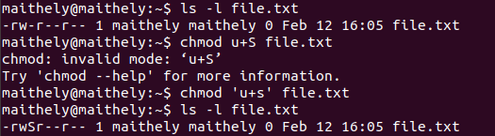

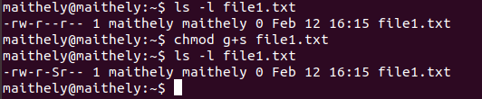

1. What is the use of Sticky bit.

When a directory has the sticky bit set, its files can be deleted or renamed only by the file owner, directory owner and the root user.

Chmod +t

1. Create a user and add it to one secondary group.

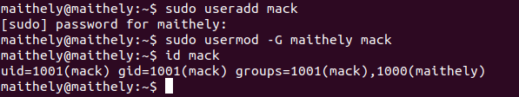

1. Lock this user.

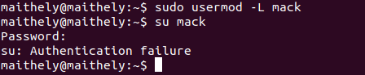

1. Give this user full access (without password).

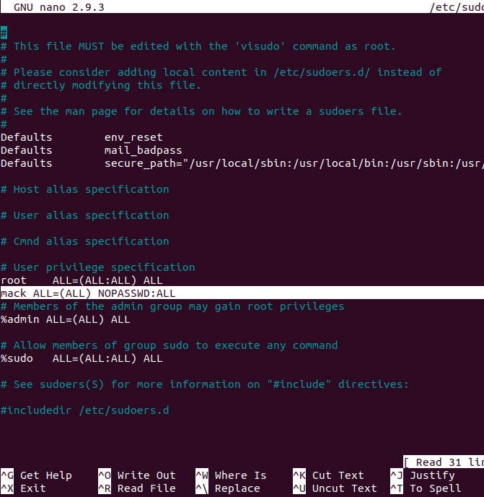

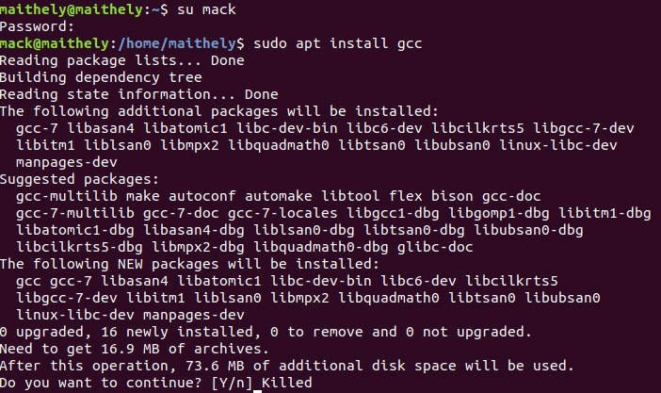

1. Delete the create user after taking backup of it home directory.

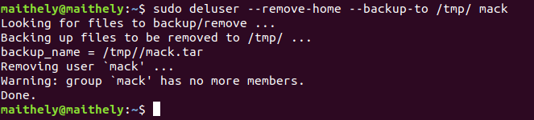

1. Create a file with some content. Change all lower case letter to upper case letter and save output to another file using redirections.

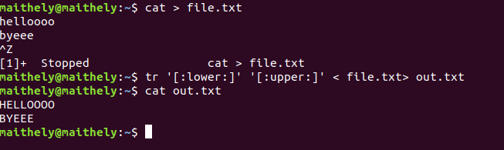

1. Set nice value of a process to -1.

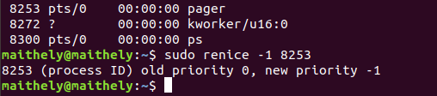

1. Get list of all files used by “telnet”.

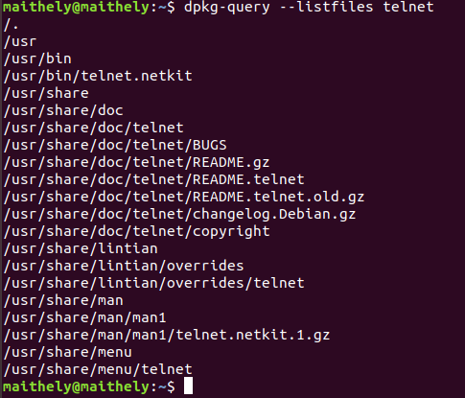

1. Check if port 22 is listening using netstat and telnet command.

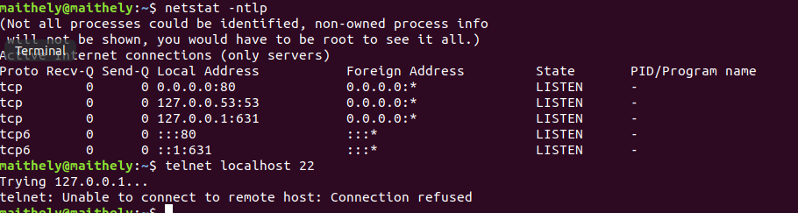

1. Create a cron job which runs once in a week at 23:45.

crontab -e

45 23 * * 1

1. Difference between dig and traceroute

**Traceroute** - The trace should have the last hop at a HostGator server.

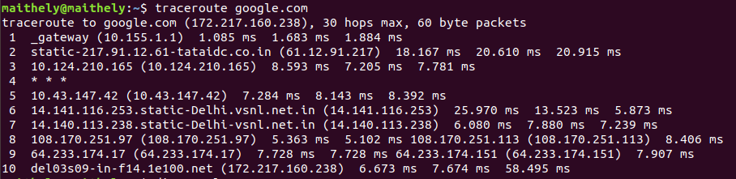

**Dig** - The Dig will be listed under *Answer Records*, showing the information from the DNS zones. This information is much more advanced.

